**Intel College Excellence Program   
Project Synopsis**

**“IOT Smart Irrigation System”**

|  |  |  |  |
| --- | --- | --- | --- |
| **Team member’s detail** | | | |
| **S. No.** | **Participant Name** | **Mobile No.** | **Email ID** |
| 1 | Chava Likhith | 9550240270 | ***Chavalikhith70@gmail.com*** |
| **Faculty(college) mentor detail** | | | |
| **S. No.** | **Mentor Name** | **Mobile No.** | **Email ID** |
| 1 | Dr. Praveen Malik | 9719437711 | ***Praveen.23314@lpu.co.in*** |
| **College/University Name** | | | |
| ***Lovely Professional University*** | | | |

**BACKGROUND**

Water scarcity and inefficient water usage are significant challenges faced by the agricultural sector worldwide. Traditional irrigation methods often rely on manual intervention or predetermined schedules, leading to overwatering or underwatering of crops. This not only wastes water but also adversely affects crop yield and quality. With the advent of IoT (Internet of Things) technology, there has been a growing interest in developing smart solutions for agriculture, including smart irrigation systems. These systems leverage sensors, actuators, and data analytics to monitor environmental conditions in real-time and optimize water usage accordingly. The motivation behind this project stems from the pressing need to address water scarcity and enhance agricultural productivity sustainably. By integrating IoT technologies with irrigation systems. Improve water efficiency: By accurately measuring soil moisture levels and environmental parameters such as rainfall and temperature, the IoT Smart Irrigation System can adjust irrigation schedules dynamically, ensuring that crops receive the right amount of water at the right time. Optimize crop yield and quality: Maintaining optimal soil moisture levels is crucial for promoting healthy plant growth and maximizing crop yield. By preventing under or overwatering, the system can help farmers achieve better crop quality and higher yields. Reduce labor and resource costs: Automating irrigation processes through IoT technology can reduce the need for manual labor and minimize water wastage, leading to cost savings for farmers and promoting sustainable agricultural practices.

**PROBLEM IDENTIFICATION**

Water scarcity is a critical issue affecting agricultural regions worldwide, exacerbated by factors such as climate change and population growth. Traditional irrigation methods often result in inefficient water usage, with significant amounts of water wasted through overwatering or runoff. Many conventional irrigation systems lack real-time monitoring capabilities, relying on fixed schedules or manual intervention. Without continuous monitoring of soil moisture levels and environmental conditions, it's challenging to adjust irrigation schedules accurately to meet the needs of crops. Inconsistent or inadequate irrigation can lead to suboptimal crop growth, reduced yield, and poor- quality produce. Maintaining optimal soil moisture levels is essential for promoting healthy root development, nutrient uptake, and overall plant health. Sustainable water management practices are crucial for mitigating the environmental impact of agriculture, including soil degradation and water pollution. Adopting smart irrigation technologies can help conserve water resources, reduce energy consumption, and minimize the ecological footprint of agricultural activities.

**PROPOSED SOLUTION**

**Real-time Monitoring and Control:** The IoT Smart Irrigation System incorporates sensors for real-time monitoring of soil moisture levels, rainfall, temperature, and humidity. We can get continuously collecting data from these sensors, the system can dynamically adjust irrigation schedules to meet the specific water needs of crops.

**Optimized Water Usage:** Utilizing a combination of soil moisture sensors and environmental data, the system employs adaptive control algorithms to optimize water usage. By ensuring that irrigation is applied only when necessary and in the right amounts, the system minimizes water waste and promotes efficient water management.

**Enhanced Crop Yield and Quality:** Maintaining optimal soil moisture levels and environmental conditions is essential for promoting healthy plant growth and maximizing crop yield. The IoT Smart Irrigation System enables precise control over irrigation, leading to improved crop quality, increased yield, and better overall farm productivity.

**Labor and Resource Efficiency:** Automation of irrigation processes reduces the need for manual intervention, saving farmers time and labor. By optimizing water usage and minimizing energy consumption, the system helps reduce operational costs and resource wastage, making irrigation management more efficient and cost-effective.

**Environmental Sustainability:** Through its ability to optimize water usage and promote efficient irrigation practices, the IoT Smart Irrigation System contributes to environmental sustainability. By conserving water resources and minimizing the ecological footprint of agriculture, the system supports the long-term health and resilience of agricultural ecosystems.

**COMPONENTS REQUIRED**

*If we want to implement the IOT Smart Irrigation System these are the components required:*

*1.* *Arduino Uno*

*2.* Soil Moisture Sensor

3. DHT22

4. Rain Detector Sensor

5. Jumper Wires.

6. Arduino IDE Software

**Flow Charts & DESCRIPTION**

*The IoT Smart Irrigation System is a technological solution designed to address the challenges of traditional irrigation methods by leveraging IoT (Internet of Things) technology. It aims to optimize water usage in agriculture by providing real-time monitoring and control of irrigation processes based on environmental conditions.*

**Arduino Uno:** The Arduino Uno is a microcontroller board based on the ATmega328P chip. It serves as the central processing unit of the irrigation system. It receives input from various sensors, processes data, and controls the irrigation process based on predefined algorithms. Arduino Uno is chosen for its ease of use, wide availability, and compatibility with a range of sensors and peripherals.

**Soil Moisture Sensor:** The soil moisture sensor measures the volumetric water content in the soil. Typically, it consists of two electrodes that measure the resistance between them, which correlates with soil moisture levels. This sensor provides crucial information about soil hydration levels, allowing the system to determine when irrigation is required.

**DHT22 Sensor:** The DHT22 sensor is a digital temperature and humidity sensor. It provides accurate readings of temperature and relative humidity, which are important environmental parameters affecting plant growth. The DHT22 sensor helps the system to monitor and adjust irrigation schedules based on temperature and humidity conditions.

**Rain Sensor:** The rain sensor detects the presence of rainfall or moisture on its surface. It typically consists of a conducting surface that detects water droplets and triggers an output signal when wet.

The rain sensor prevents unnecessary irrigation during rainy weather by pausing the irrigation process when rainfall is detected.

**5V Pump:** The 5V pump is responsible for delivering water from a water source (e.g., tank, reservoir) to the irrigation system. It is controlled by the relay module, which activates the pump when irrigation is needed and deactivates it when the desired moisture level is reached. The pump ensures efficient water distribution to crops, promoting healthy growth and maximizing crop yield.

START

Initialize System

Initialize Sensors

Initialize Communication

Read Sensor Soil Moisture, Rainfall Status,

Temperature and Humidity

Analyze Data and Determine the Irrigation Needs.

Example: Turn on Pump if Soil moisture < Threshold Value

Display Sensor Reading and Irrigation Status

Repeat

**OUTPUT**

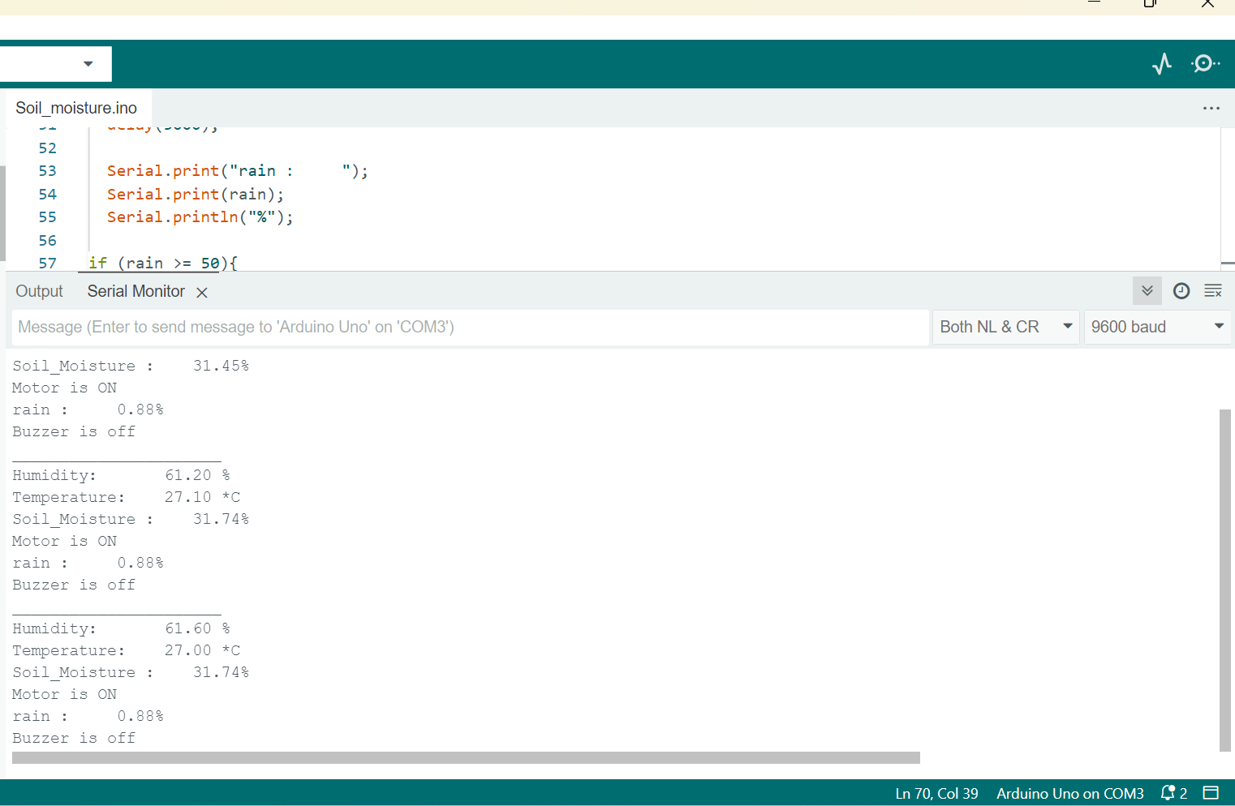

**Hardware Connection and circuit**

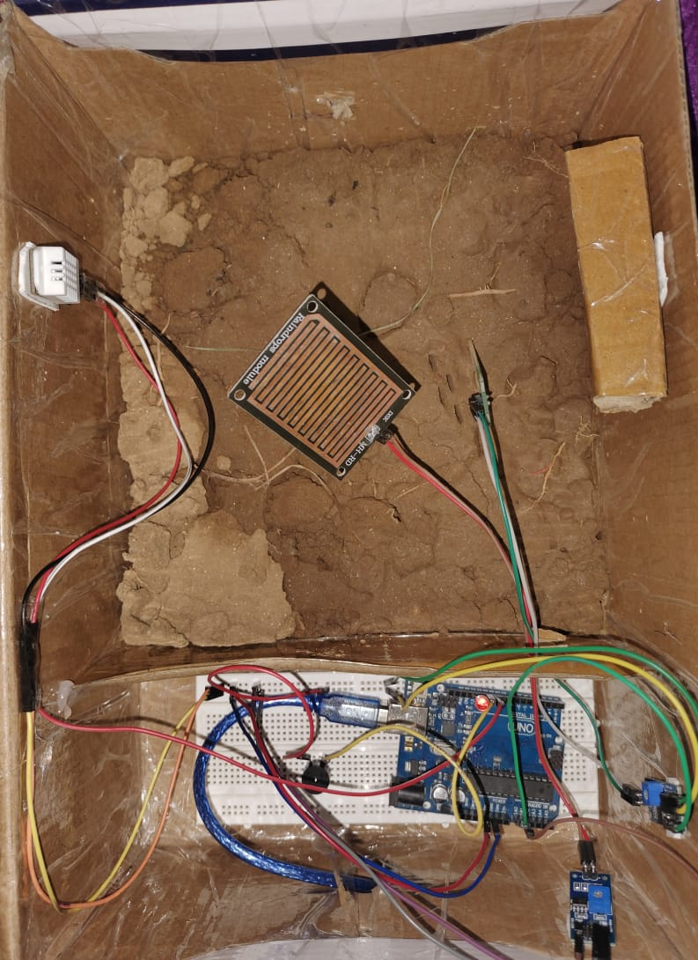

**CODE**

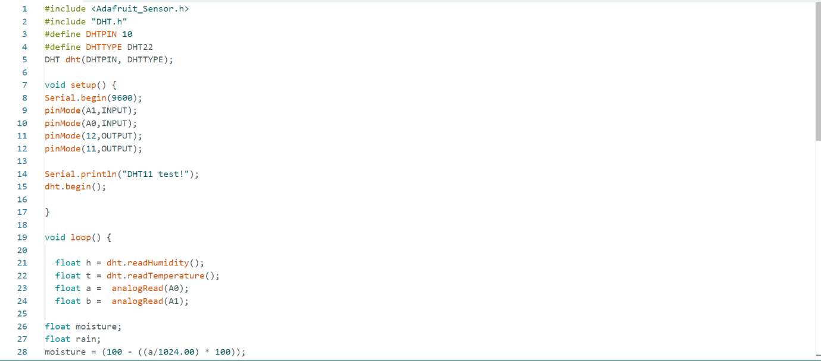

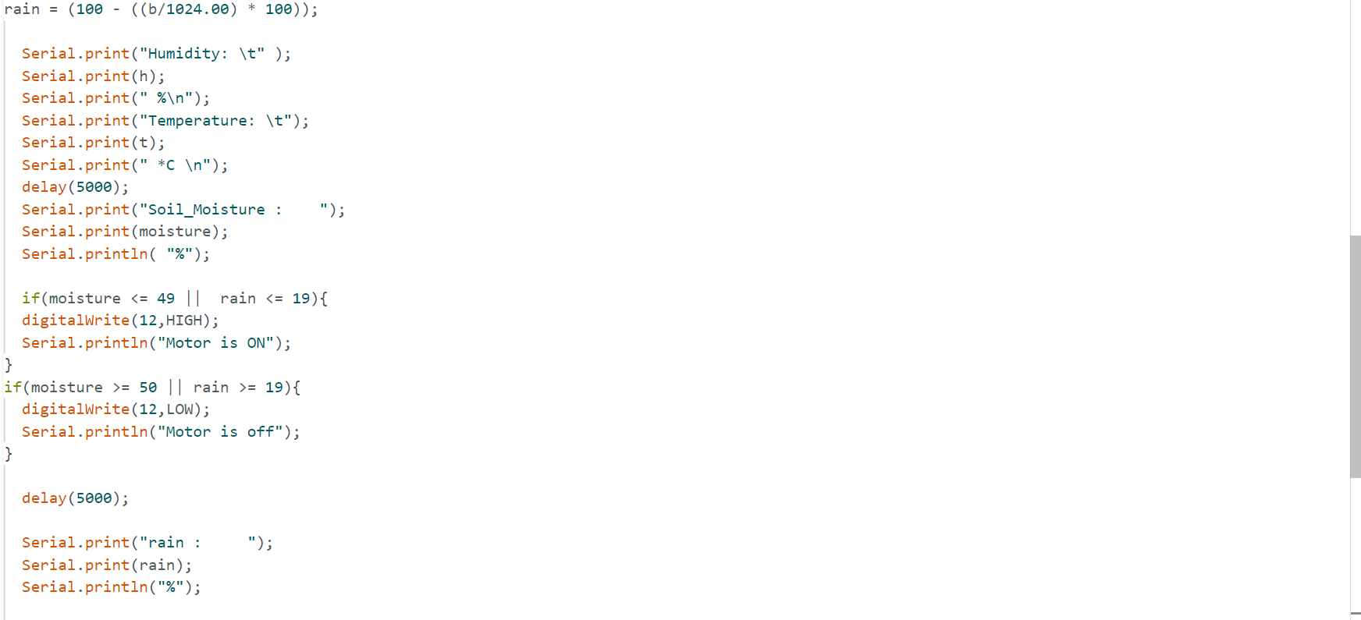

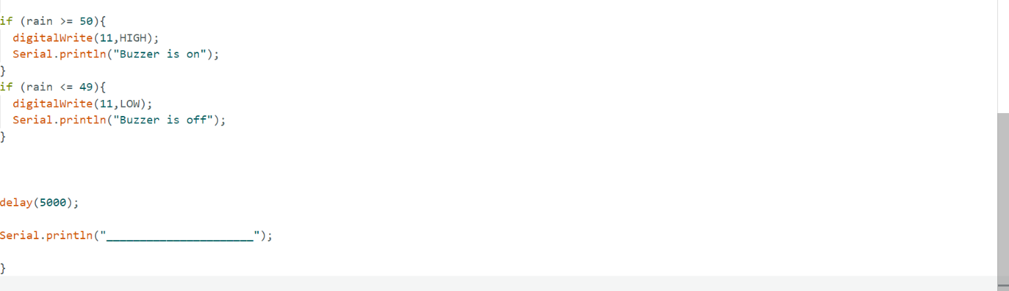

**Software Simulation**

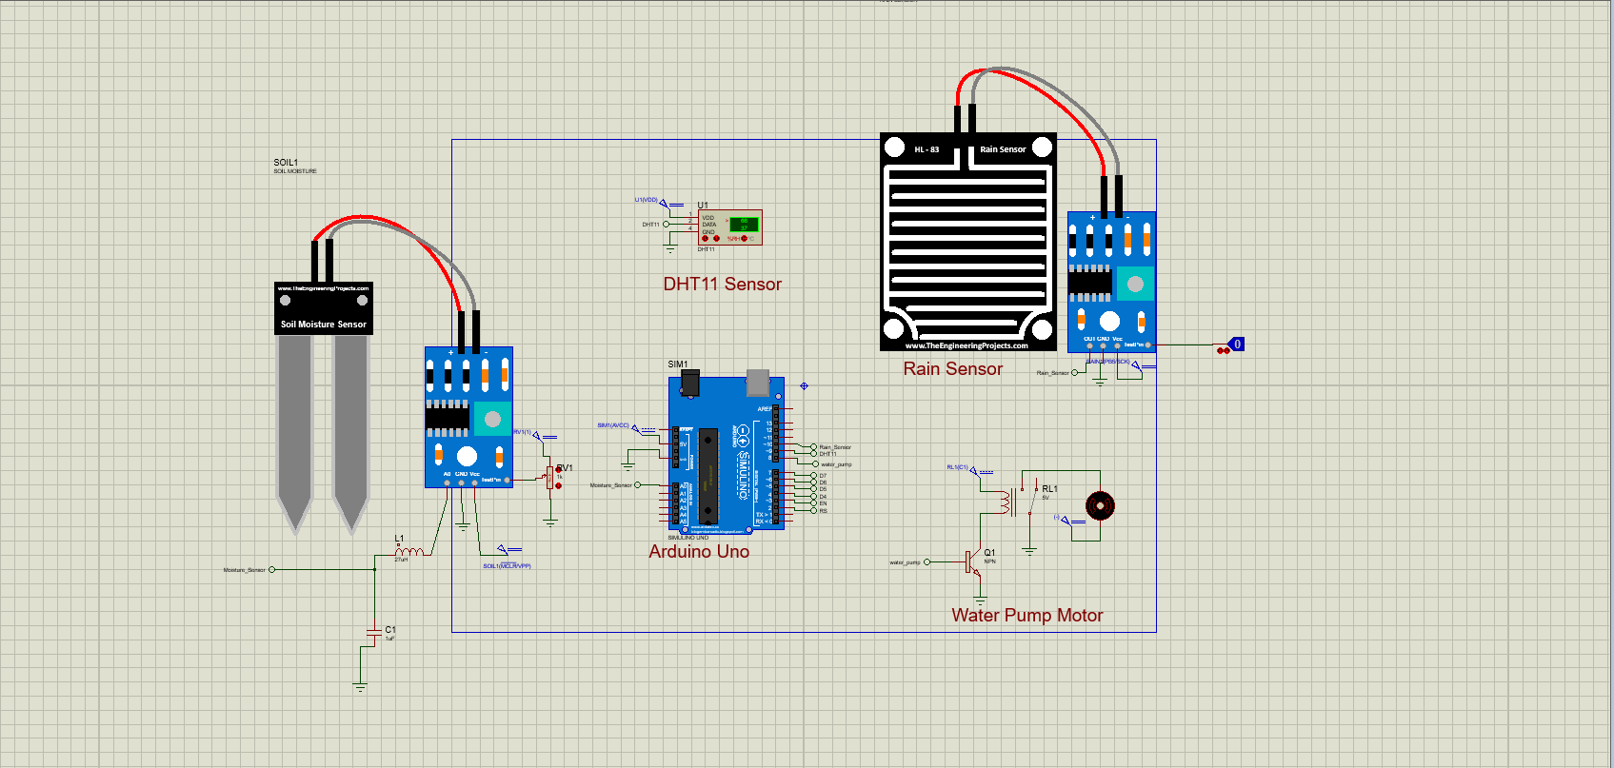

**FUTURE SCOPE**

Implementing wireless communication protocols such as Wi-Fi or LoRa allows for remote monitoring and control of the irrigation system. Wireless connectivity enables farmers to access real-time data and manage irrigation schedules from anywhere, enhancing convenience and flexibility.

Utilizing advanced data analytics techniques and machine learning algorithms can optimize irrigation schedules based on historical data and predictive models. Machine learning algorithms can analyze complex environmental datasets to provide personalized recommendations for irrigation management, improving water efficiency and crop yield.

**CONCLUSION**

Utilizing advanced data analytics techniques and machine learning algorithms can optimize irrigation schedules based on historical data and predictive models. Machine learning algorithms can analyze complex environmental datasets to provide personalized recommendations for irrigation management, improving water efficiency and crop yield. Through the integration of sensors, microcontrollers, and data analytics, the IoT Smart Irrigation System enables precise irrigation scheduling based on soil moisture levels, rainfall, temperature, and humidity conditions. This ensures that crops receive the right amount of water at the right time, minimizing water wastage and promoting healthy plant growth.

**REFERENCES**

*<* *https://github.com/LikhithChava/IOT_Smart_Irrigation_System>*

**THANK YOU TO FICE**